**Project Development Phase**

|  |  |
| --- | --- |
| **Date** | **08 November 2022** |
| **Team ID** | **PNT2022TMID50712** |
| **Project Name** | **Smart Fashion Recommender Application** |

**INTEGRATING CHATBOT WITH HTML PAGE (SOURCE CODE):**

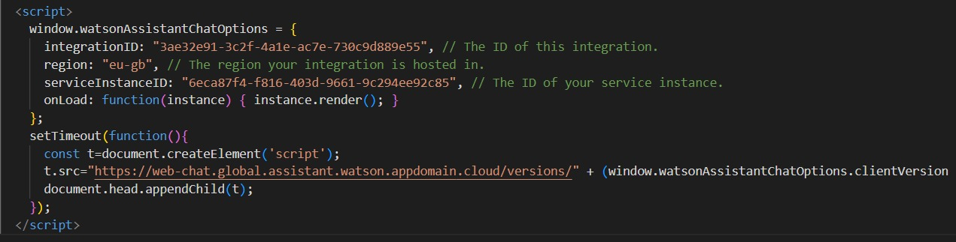

**INTEGRATING CHATBOT WITH HTML PAGE:**

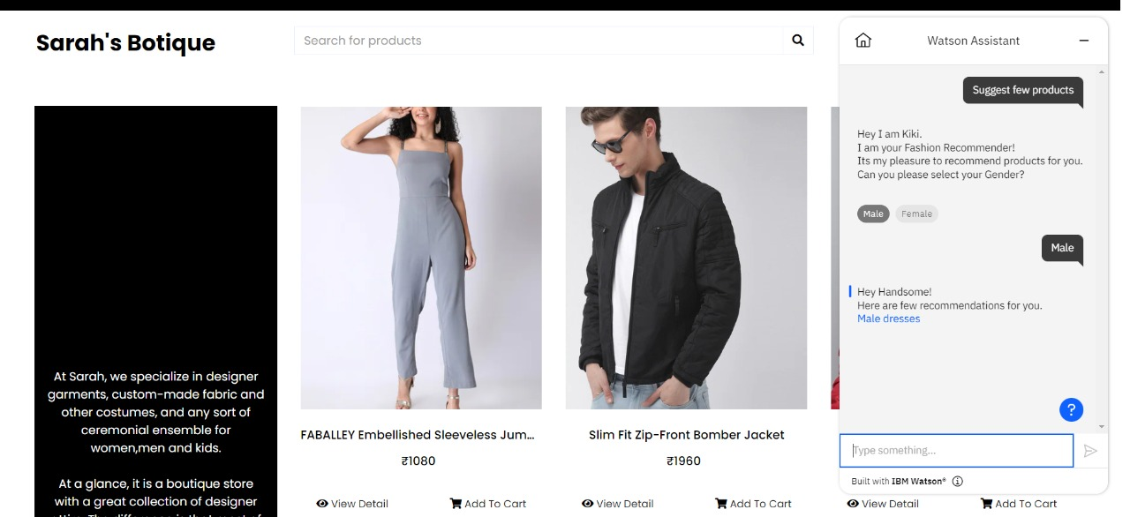

**DOCKER PUSH:**

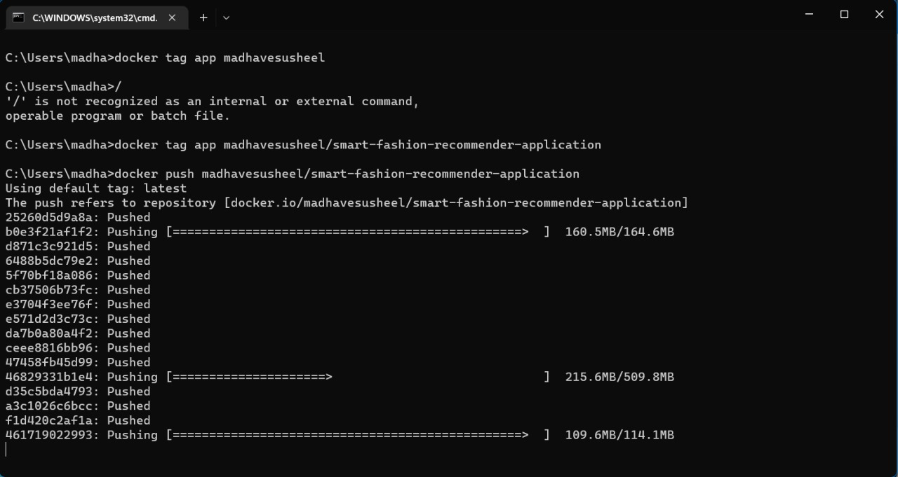

**CONTAINERIZING THE APPLICATION:**

